FDP
on
The Art of Writing Winnable Project Proposal for Funding
09.01.2020

About the Institute
Annamacharya Institute of Technology and Sciences, Tirupati was established in the year 2007 in a 40 acre sprawling green campus with serene atmosphere and congenial learning practices. The institute offers five streams in engineering namely CSE, ECE, EEE, and Civil & Mechanical Engineering. It also runs two post graduate programmes - M.Tech & MBA. The institute provides adequate practical orientation to students in order to make them succeed in the present day competitive world.
About Department of Management Studies
The department, established in 2008 has been able to impart quality managerial competencies for students with qualified, experienced and senior faculty members including Doctorates. The department offers premier professional training that keeps the students in pace with the latest developments in the field of Business Management. The department regularly conducts Personality Development courses, Soft skill courses and employment oriented courses for providing the students a clear and decisive edge in employability through modular and supplementary programs based on industry tracking and feedback. The department has forged strong Institute-Industry Interface with leading companies to continuously bridge the gap between college education and Industry needs through summer Internships, pre-employment training programs, guest lectures and other Interaction programs.
About the FDP
The one day FDP on The Art of Writing Winnable Project Proposal for Funding covers different aspects of writing effective project proposal which makes it easy to qualify for approval for funding agencies. It also provides a glimpse of various funding agencies, best practices about writing literature reviews and hands-on training on literature. It will bring a positive transformation in the faculty members’ attitude in submitting effective proposals .

ANNAMACHARYA INSTITUTE OF TECHNOLOGY AND SCIENCES::TIRUPATI
DEPARTMENT OF MANAGEMENT STUDIES

Faculty Development Programme
on
THE ART OF WRITING WINNABLE PROJECT PROPOSAL FOR FUNDING
On
09.01.2020
Program Schedule
9:30 a.m to 9:45 a.m. | Inaugural session
9:45 a.m. to 11:00 a.m. | Session I: How to write a winnable project proposal
11:00 a.m. to 11:15 a.m. | Tea break
11:15 a.m. to 12:30 p.m. | Session II: Preparations required for writing proposals
12:30 p.m to 1:30 p.m. | Lunch
1:30 p.m to 3:00 p.m. | Session III: Funding Agencies
3:00 p.m to 3:15 p.m. | Tea Break
3:15 p.m to 4:30 p.m. | Session IV: Hands on training on Literature and Patent search

REPORT ON THE EVENT
The FDP on “The Art of writing winnable project proposal for funding” was organized in a grand manner in AITS, Tirupati on 9.1.2020.The Department of Management Studies organized the workshop in the e-classroom and faculty members from different colleges in and around A.P. participated in the FDP. Dr M. Kantha Babu, Director, Centre for IPR, College of Engineering , Anna University, Chennai, has been the Resource Person for the workshop. Dr.Haritha Kasumarthi, Head, Department of Management Studies was the Convener for workshop.

PARTICIPANTS:
Around 42 participants (faculty members) from various colleges in and around A.P have participated in the workshop.(List enclosed)

FEEDBACK OF PARTICIPANTS
- I have learnt to identify novel ideas to write and win funding projects from government. Programme was very useful
----- P Revathi , Research Scholar, Bharathiar University, Coimbatore.
- This programme has improved my knowledge in the field of IPR and getting funding for projects ---- P Srinivas, Asst Professor in Law, Anantha Law College, Tirupati.
- Got exposure about research proposals and patent rights. It was a good experience.
---Dr N Deepak Kumar, Professor, SRET, Tirupati
- This programme has given new insights for us in the area of IPR.
–Mr S M K Sukumar Reddy, Asst Professor, VITS, Proddatur
- The programme was very interesting and a wonderful opportunity to gain insights into writing proposals and getting them funded.
-------Mr. Ch Venkateswarulu, Asst Porfessor-MBA, AITS, Tirupati

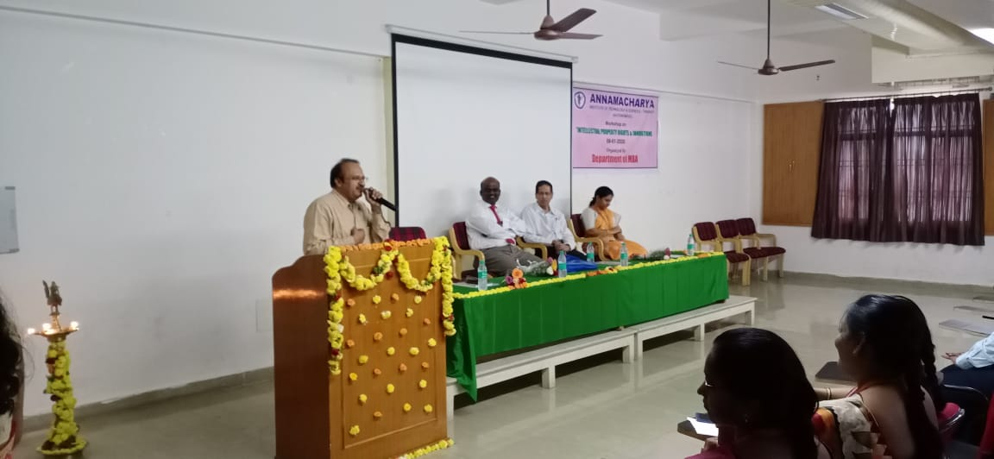
Fig: Speech by The Principal, Dr Nadhamuni Reddy

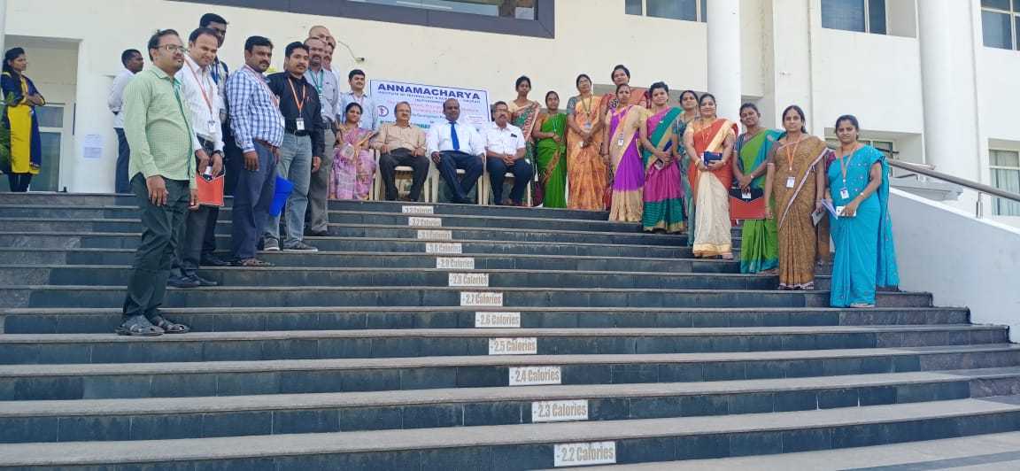
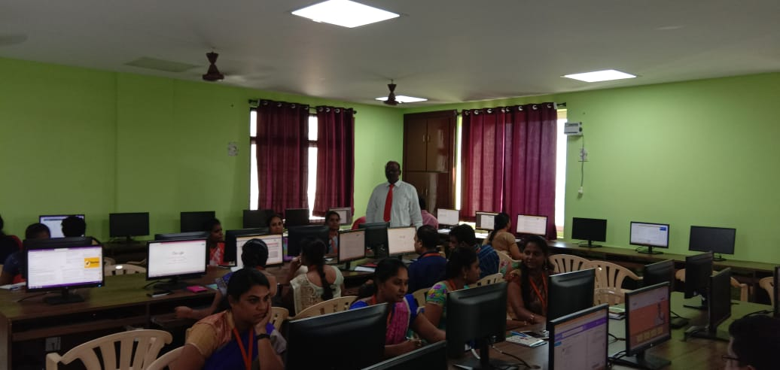
Fig. Participants of the Workshop in the Lab

